How to install Facelock on Windows OS

1. Source Code:



1. Install Dlib Python API on Windows PC <https://www.youtube.com/watch?v=Q4_M8YTAPDg>

* Follow EVERY step in this video.

1. Install Python 2 (Such as Python 2.7.15 <https://www.python.org/downloads/release/python-2715/> )
2. Run this command: “pip install Django”

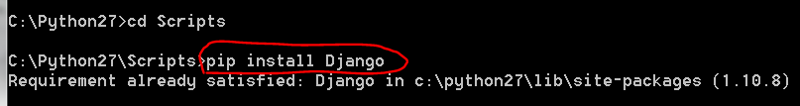

1. Run “pip install cmake” (Action: install cmake)
2. Run “pip install face_recognition”
3. Run “pip install opencv-python” (Action: Install openCv)

1. Run “pip install --upgrade google-api-python-client” (Action: to configure google vision api)

Rnu “pip install --upgrade google-cloud”

Run “pip install --upgrade google-cloud-vision”

1. Run “pip install **scipy**” (Action: Install scipy)

1. Run “**pip install PyHamcrest**”

1. Run “pip install argparse”
2. Attention: above command must run at path: **C:\Python27\Scripts** (Not necessary Python27, but must be in Python **2** ), and using “**Anaconda Prompt**”
3. Add PATH

* GOOGLE_APPLICATION_CREDENTIALS
* facelock-aee2366fc392.json file

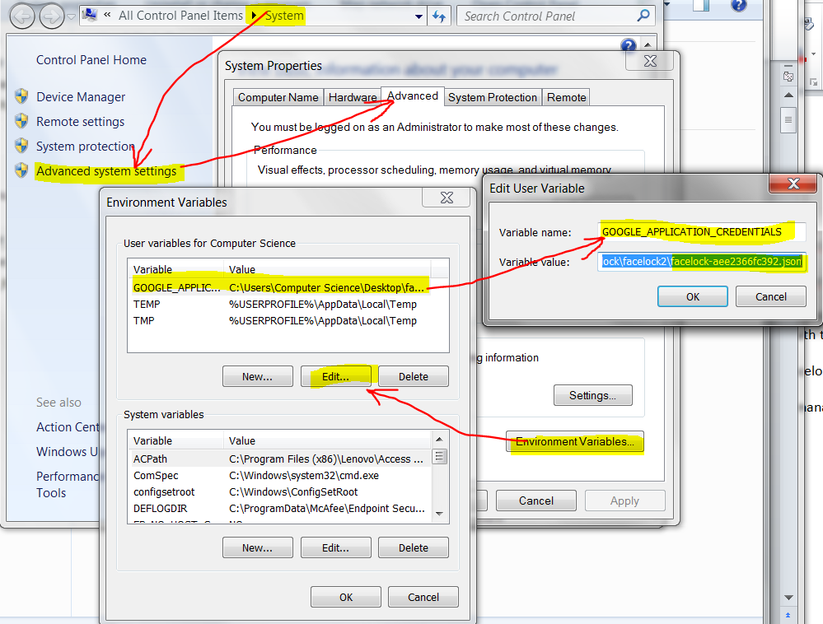

1. Keep below JSON file updated via Google Cloud Account.

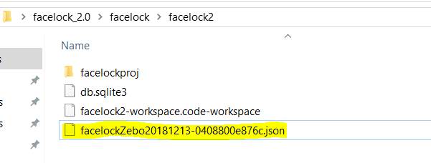

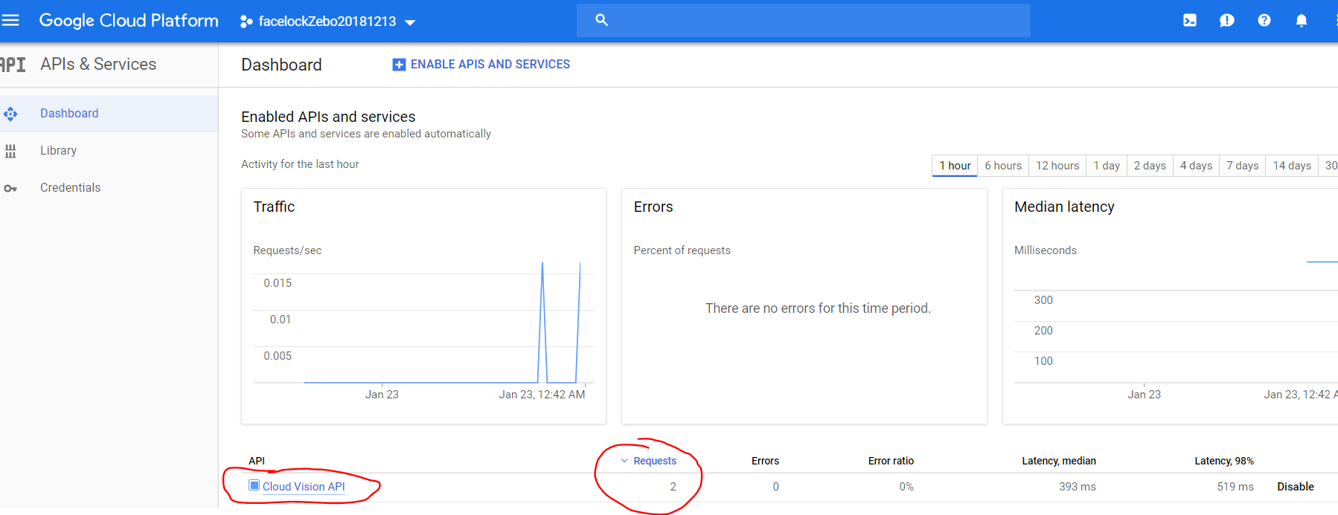

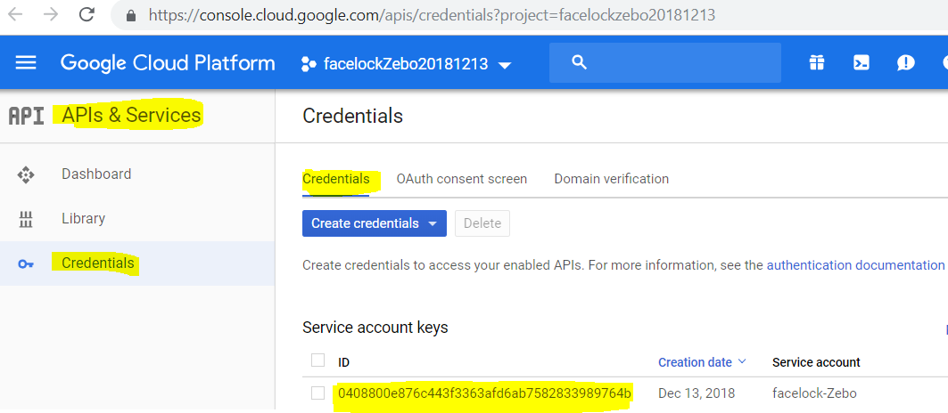

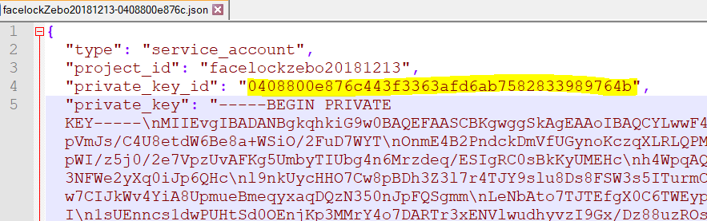

1. Install “DB Browser for SQLite” <https://sqlitebrowser.org/>

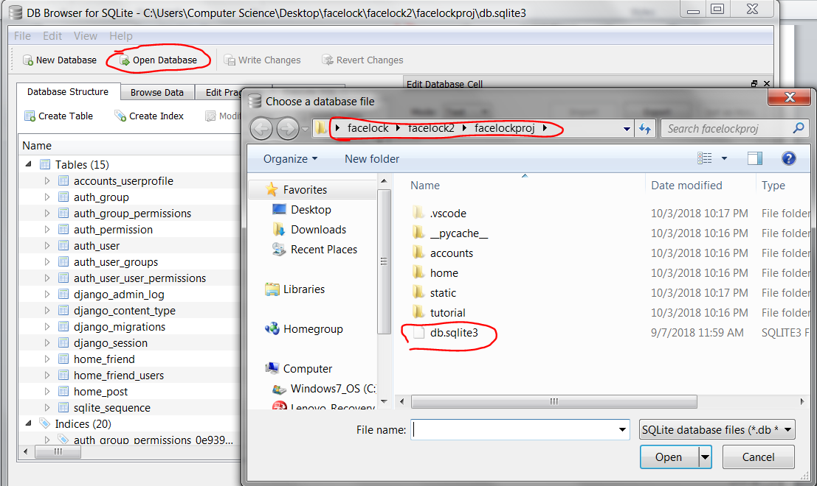

1. Run “python manage.py runserver”

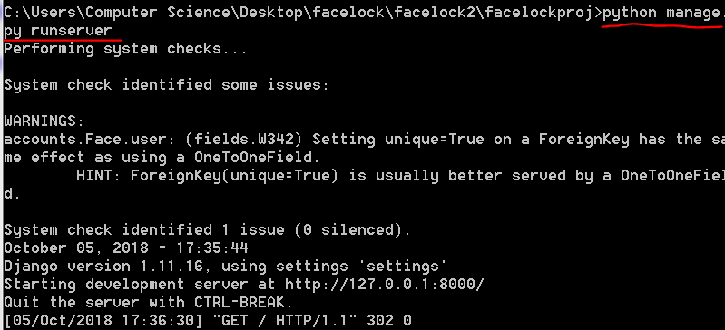

1. Open webpage: <http://127.0.0.1:8000/> and login as:

* Donald Trump: Username: donald | Password: donalddonald
* MelaniaTrump: Username: melania | Password: melaniamelania
* Barack Hussein Obama: Username: obama | Password: obamaobama
* Michelle Obama: Username: michelle | Password: michellemichelle
* Hillary Clinton: Username: hillary | Password: hillaryhillary